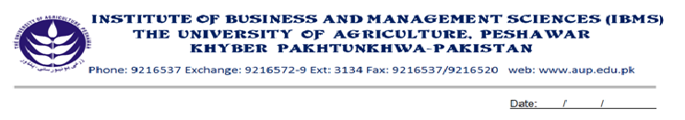Programme: BS (IT) - III
Course Name: Modern Programming Languages-I
Course Code: IT-403
Course Hours: 03
Total Weeks: 16
Total Hours: 48

Course Objectives

The aim of this course is to teach a full Structure & object oriented programming overviews and specially getting expertise in Java application programming. In this course students learn about Java fundamentals, Java application, Java exception handling, Java object oriented model and packages. This course also covers Java GUI programming which includes AWT packages. This course will prepare students for Modern Programming Languages II, which is the continuation of this course.

Week-1
- Introduction to Java
- Java API
- Java Application Types
1. Java Application programming
2. Java Applet Programming
- Java Program Structure

Week-2
-Language Fundamentals
-Keywords and identifiers
-Primitive Data Types
-Integer Data types
-Floating Point Data Types
-Variables
-Declaring a Variable

Week-3
-Operators and Assignments
1- Evaluation Order
2- The unary Operators
3- The Increment and Decrement Operators ++ and -
4- The unary + and — Operators
5- The Arithmetic Operators
6- The Multiplication and division Operators:* and /
7- The Modulo Operator: %
8- The Addition and subtraction Operators: + and -
9- Comparison with <,<=,> and >=
10- Logical Operators

Week-4
-If Condition & if Else
-The While () Loop
-The do Loop
-The For () Loop

Week-5
-The Break and continue Statements in Loops
-Using break
-Using continue
-The switch () Construct

Week-6
-Static Methods & their calling
-Parameter passing to static methods

Week-7
-Introduction to Arrays
-One & Two Dimension array

Week-8
-Class Fundamentals
-The general form of a class
-Declaring Objects
-Introducing Methods
-Adding method to the class
-Returning a value
-Adding a method that takes parameters

Week-9
-Constructors
-Constructor overloading
-The this keyword
-Garbage Collector

Week-10:
-Method Overloading
-Inheritance
-Inheritance Basics
-Using super

Week-11
-Method Overriding
-Using final with in Inheritance
-Using final to prevent overriding
-Using final to prevent Inheritance

Week-12
-What is Exception?
-Why we handle them
-Exception Major types
-Try catch finally blocks

Week-13
-What is meant by Packages in Java
-Introduction of java. AWT Package

Week-14
-Creating Frame
-Creating panels

Week-15
-Layout Mangers
1. Border Layout
2. Grid layout
3. Flow layout
Week-16
-Creating & adding following GUI objects in Containers i.e.
1. Buttons
2. Text Fields
3. Labels

Recommended Books

1. Sun Java programming student guide
By Sun Microsystems.
2. Beginning Java 2
By lvor Horton.

